NOTIFICATION
DEPARTMENT OF CHEMISTRY
UNIVERSITY OF ALLAHABAD
(22/06/2021)

All the candidates who have qualified CRET 2020 Level-II test in Chemistry and all candidates who are exempted from the test as per University of Allahabad ordinances for Research are requested to submit photocopies of following documents in the office of the Department of Chemistry, University of Allahabad till 30th June 2021. Please bring originals of the documents for verification.
- Admit Card of CRET-2020
- High school Mark sheet & Certificate
- Intermediate Mark sheet & Certificate
- Graduation Mark sheet and Certificate
- Post graduation Mark sheet and Certificate
- NET/JRF certificate in applicable
- Score Card of CRET-2020 Level-I/JRF if Applicable
- Caste Certificate (OBC/SC/ST) in Central Government format
- EWS Certificate in Central Government format, if applicable
- pH Certificate if Applicable
- Adhar-Card
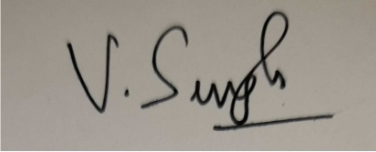

CHAIRPERSON
CRET ADMISSION-2020
UNIVERSITY OF ALLAHABAD

NOTIFICATION
DEPARTMENT OF CHEMISTRY
UNIVERSITY OF ALLAHABAD
(22/06/2021)

All the candidates who have qualified CRET 2020 Level-II test in Agricultural Chemistry and scored 139 or above are requested to submit photocopies of following documents in the office of the Department of Chemistry, University of Allahabad till 30th June 2021. Please bring originals of the documents for verification.
- Admit Card of CRET-2020
- High school Mark sheet & Certificate
- Intermediate Mark sheet & Certificate
- Graduation Mark sheet and Certificate
- Post graduation Mark sheet and Certificate
- NET/JRF certificate in applicable
- Score Card of CRET-2020 Level-I/JRF if Applicable
- Caste Certificate (OBC/SC/ST) in Central Government format
- EWS Certificate in Central Government format, if applicable
- pH Certificate if Applicable
- Adhar-Card

CHAIRPERSON
CRET ADMISSION-2020
UNIVERSITY OF ALLAHABAD

